PHASE 08 DEMONSTRATION

PocketSmart AI Phase 8 Project Demonstration
Demo agenda, communication notes, team roles and future plan
Prepared 03 October 2026
Show how a user moves from a budget to a starter plan and saved history. Explain that estimates and retailer search links support comparison but do not verify current products, prices or availability.

Suggested six minute demonstration
Time | Demonstration step | What to explain
0:00 to 0:40 | Introduce the problem and three planners. | One app supports home, party and jewelry planning.
0:40 to 1:20 | Show registration or sign-in and dashboard. | Plans are associated with the signed-in account.
1:20 to 2:30 | Submit a Home plan. | Show rooms, item quantities, estimates and search links.
2:30 to 3:30 | Submit a Party plan. | Show event type, guest count and priorities.
3:30 to 4:30 | Submit a Jewelry plan; optionally show image input. | Explain image use and optional Gemini.
4:30 to 5:10 | Open History and revisit a saved plan. | Show how saved recommendations can be reopened.
5:10 to 6:00 | Close with boundaries and next steps. | Clarify estimates, search links and future validation.

Communication points
- Say “estimated planning amount” rather than “current price” or “quote.”
- Say “retailer search link” rather than “verified product recommendation.”
- Gemini is optional; local planning remains available without a key or after a Gemini failure.
- Do not show or read secret values from .env during a presentation.
- Use a demo account and non-sensitive sample preferences; check the database before screen sharing.

Suggested demonstration roles
Role | Responsibility
Presenter | Introduces the problem, explains the workflow and states recommendation boundaries.
Operator | Runs the prepared account and planner scenarios, then opens History.
Observer or note taker | Tracks questions, timing, unexpected behavior and follow-up items.

Scalability and future plan
Priority | Potential next step | Reason
1 | Run user interviews and usability sessions for the three planner flows. | Validate ideation assumptions and improve unclear inputs.
2 | Run repeatable functional and performance checks and record baselines. | Set evidence-based limits for latency, concurrency and failure handling.
3 | Pass the configured Gemini timeout into the generation call and review retries. | The setting exists but is not passed to the current generation call.
4 | Assess PostgreSQL and managed deployment before scaling past one local instance. | SQLite is a local default; multi-instance use needs a tested storage design.
5 | Add operational monitoring, retention controls and backup/restore procedures. | Improve support and data stewardship before production use.

Demonstration screenshots
These captures come from the supplied PocketSmart AI project guide. The filled account form uses documentation examples, not a live account.
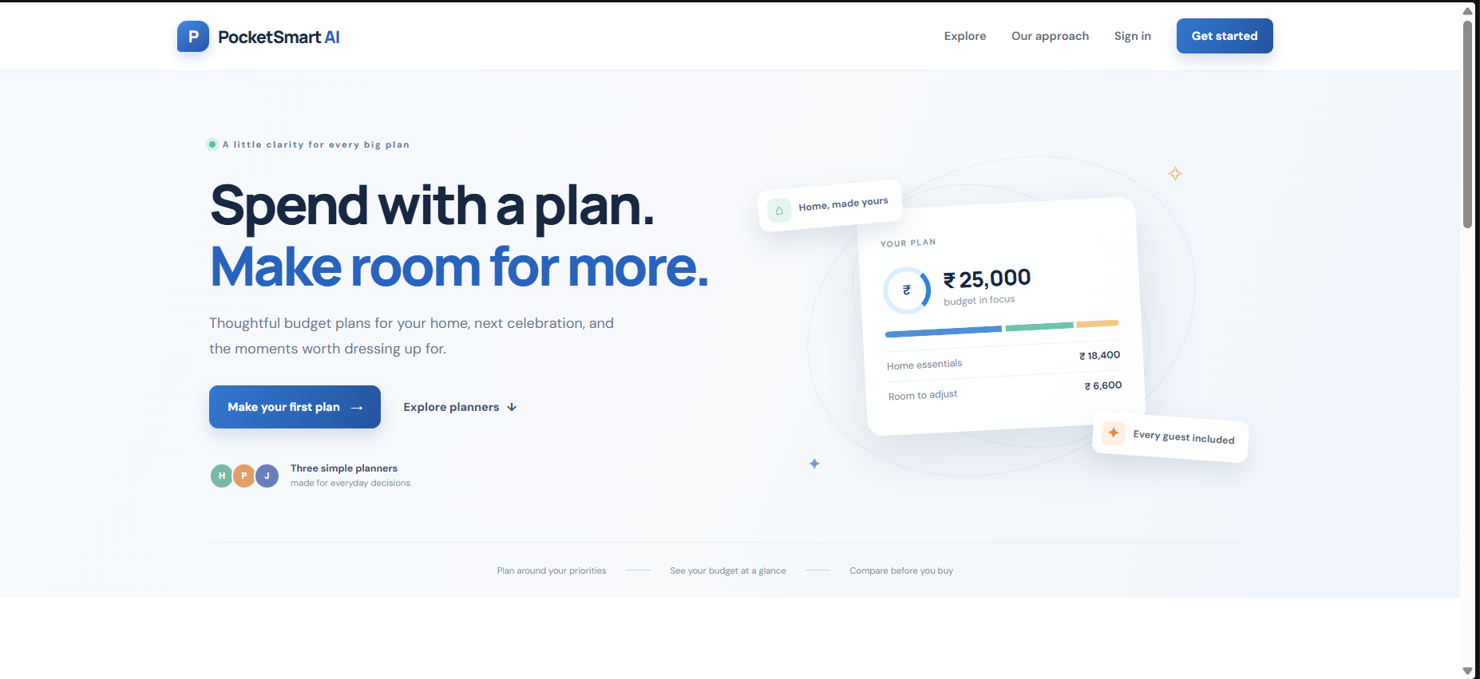
Figure 1. PocketSmart AI landing page and planner entry points.
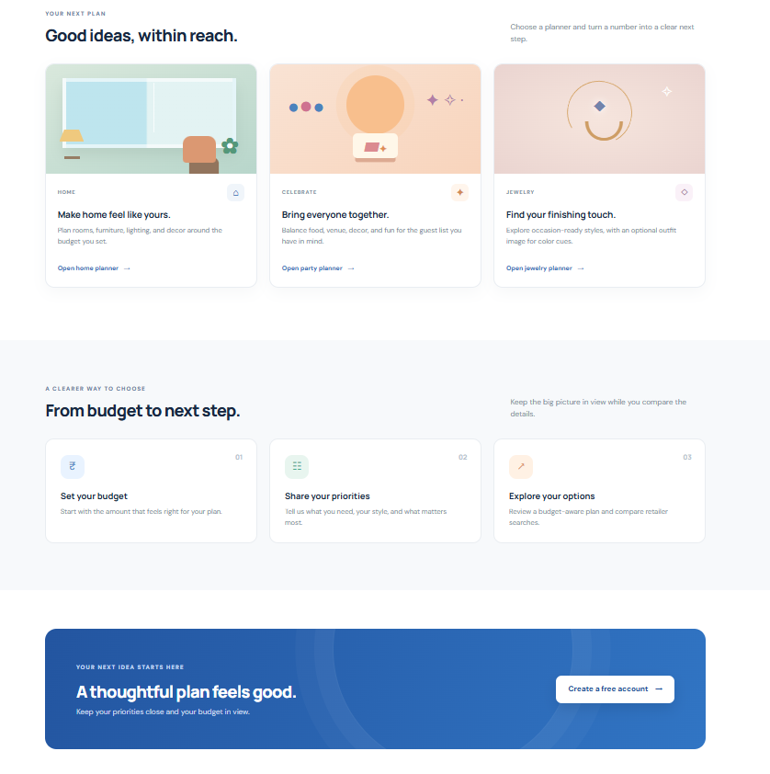
Figure 2. Planner cards and budget, priorities and options sequence.

Demonstration screenshots continued
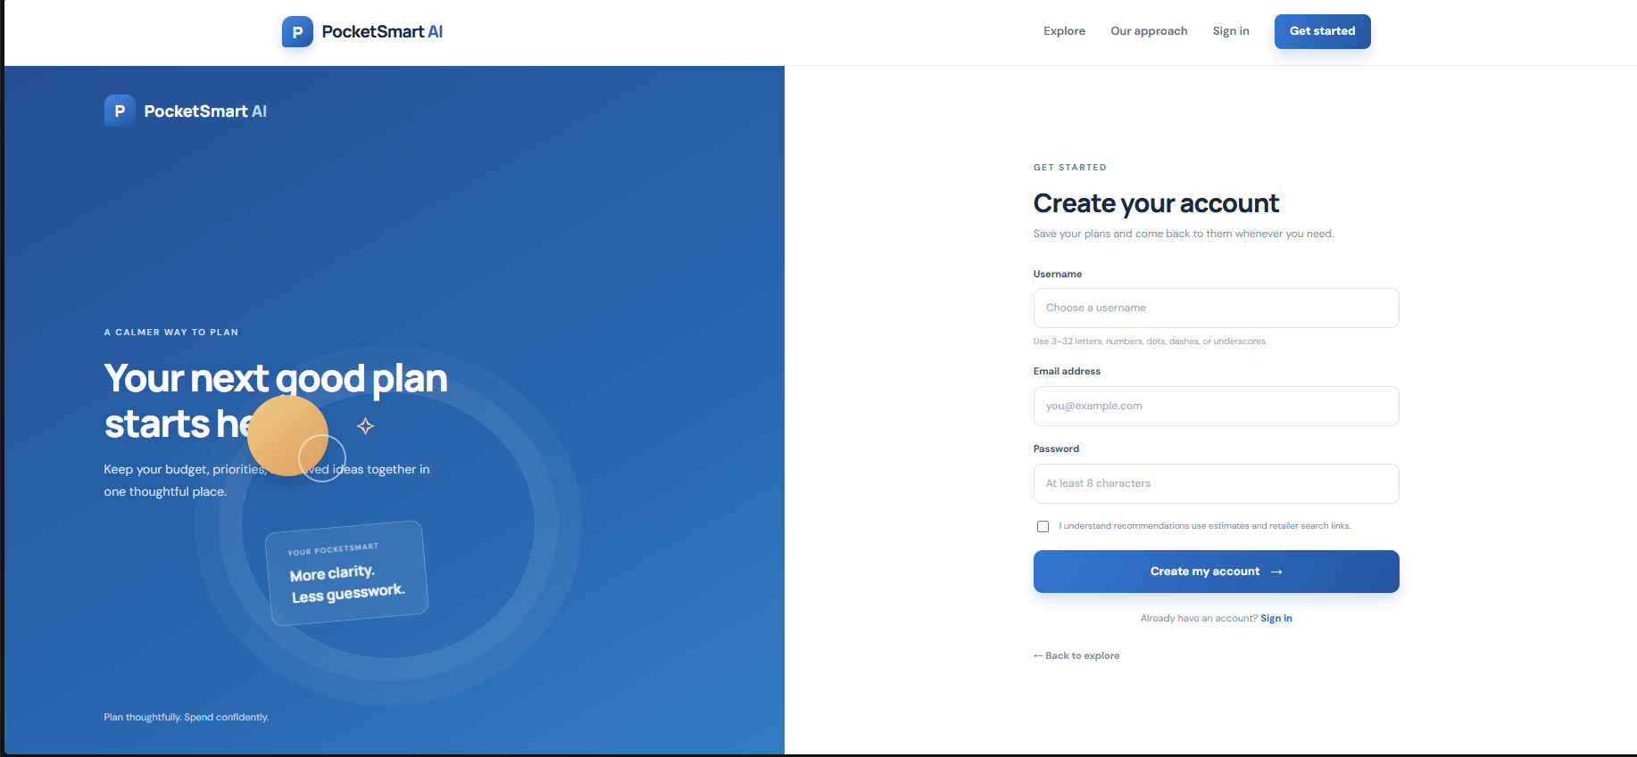
Figure 3. New account form with no personal details entered.
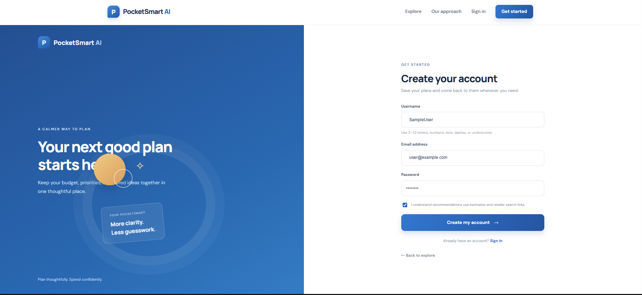
Figure 4. Account form filled with documentation example values.

